MNI SOSE
INTERTRIBAL WATER RIGHTS COALITION
514 Mt. Rushmore Road, PO Box 2890
Rapid City, SD 57709-2890
(605) 343-6054 ~ (605) 343-4722 (fax)
mnisose@qwest.net www.mnisose.org

Briefing Document on the
Mni Sose Intertribal Water Rights Coalition

Member Tribes
Assiniboine & Sioux Tribes of Fort Peck, Blackfeet Nation, Cheyenne River Sioux Tribe,
Chippewa Cree Tribe of the Rocky Boy’s Reservation, Crow Tribe, Eastern Shoshone Tribe, Flandreau Santee Sioux Tribe, Fort Belknap Assiniboine & Gros Ventre Tribes, Kickapoo Tribe in Kansas, Lower Brule Sioux Tribe, Northern Arapaho Tribe, Northern Cheyenne Tribe, Omaha Tribe of Nebraska and Iowa, Ponca Tribe of Nebraska, Prairie Band Potawatomi Nation, Rosebud Sioux Tribe, Sac & Fox Nation of Missouri, Santee Sioux Nation of Nebraska, Sisseton-Wahpeton Oyate of the Lake Traverse Reservation, Spirit Lake Tribe, Three Affiliated Tribes of Fort Berthold, Turtle Mountain Band of Chippewas, Winnebago Tribe of Nebraska, Yankton Sioux Tribe

The Missouri River Basin Tribes
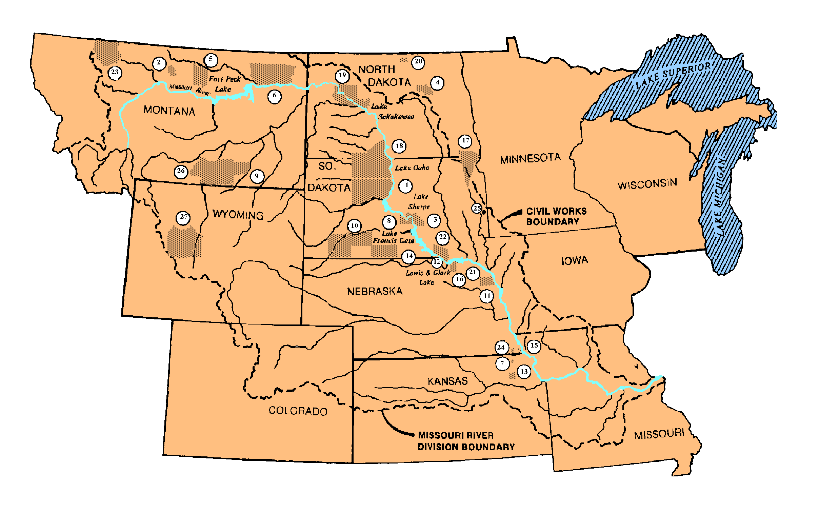

Mni Sose Intertribal Water Rights Coalition Members

1. Cheyenne River Sioux Tribe
2. Chippewa Cree Tribe
4. Spirit Lake Nation
5. Fort Belknap
6. Assiniboine & Sioux Tribes
7. Kickapoo Tribe in Kansas
8. Lower Brule Sioux Tribe
9. Northern Cheyenne Tribe

11. Omaha Tribe of Nebraska
12. Ponca Tribe of Nebraska
13. Prairie Band Potawatomi
14. Rosebud Sioux Tribe
15. Sac & Fox Nation of Missouri
16. Santee Sioux Nation
17. Sisseton-Wahpeton Oyate of
Lake Traverse Reservation
19. Three Affiliated Tribes

20. Turtle Mountain Band of Chippewa
21. Winnebago Tribe
22. Yankton Sioux Tribe
23. Blackfeet
25. Flandreau Santee Sioux Tribe
26. Crow Tribe
27. Wind River (Shoshone & Arapaho Tribes)

Non-Member Tribes: 3. Crow Creek Sioux Tribe
10. Oglala Sioux Tribe
18. Standing Rock Sioux Tribe
24. Iowa Tribe of Kansas
Mni Sose Intertribal Water Rights Coalition

The protection and management of tribal water and land resources in the Missouri River watershed are among the most critical priorities facing the 28 basin Tribes. Indian Tribes control more than 15 million acres of land within the watershed, geographically distributed from the headwaters in Montana to the mouth of the Missouri River in Kansas and Missouri. These reservations were set aside for use and development as permanent tribal homelands.

The Missouri River and its tributaries are an immense natural resource. They drain one-sixth of the Nation. The 530,000 square-mile basin is more than 2,300 miles long. Twenty-eight major reservoirs are in the basin, including the third, fourth, and fifth largest in the United States. Seven hydropower plants use the river for power generation, and 17 other power plants use the river for cooling purposes. Nearly four million people use the river for their water supply. Missouri River fisheries generate about five million recreational visits each year valued at $175 million.

Despite historical and legal rights to the water, the 25 Coalition Member Tribes have not participated fully in the benefits of the Missouri River water resources and its tributaries. Twenty-three percent of the 1,499,759 acres taken for the construction of the dams and reservoirs under the Pick-Sloan plan were lands of the Tribes. Although the federal government promised irrigation development and participation in the electricity generation, the Tribes are just beginning to receive some of these benefits.

A survey conducted by the Mni Sose Coalition reported an average education level of a high school diploma for adult tribal members among the Missouri River Basin Tribes, which results in a lack of trained tribal professionals and technicians. Scarce resources are reflected in an annual average unemployment rate of 50 percent among the Missouri River Basin Tribes. The Cheyenne River Sioux Tribe and the Rosebud Sioux Tribe report unemployment rates near 85 percent.

Tribal leaders are seeking legal, administrative, economic, and physical control over their significant water resources as a means to achieve sustainable reservation economy, cultural well-being, and sovereignty of tribal people in the watershed. The Mni Sose Intertribal Water Rights Coalition was formed as the mechanism to pursue these goals. The Great Northern Plains Tribes originally envisioned the concept of a water resource consortium as early as 1973. In January of 1993, they formally organized and recognized the Mni Sose Intertribal Water Rights Coalition.

The Coalition was established as a nonprofit organization to:
- Promote the health, education, welfare, and economic growth throughout the lands of the member Tribes, Bands, Communities, and Nations through the development, assertion, enhancement, and protection of their water rights;
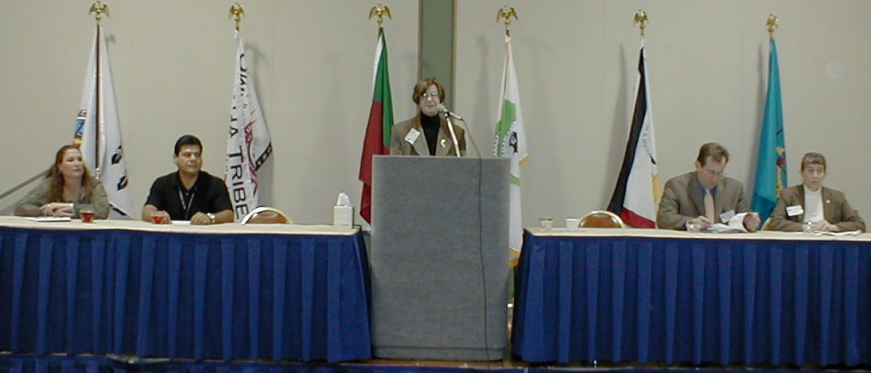
Latane Donelin from the Prairie Band Potawatomi Nation moderates the Tribal Environmental Office of the 21st Century panel for the National Tribal Environmental Enforcement and Compliance Conference Part II on November 19, 2002.
- Plan, coordinate, and prepare educational materials and training events to help the member Tribes in the development, assertion, enhancement, and protection of their water rights; and
- Obtain the human and fiscal resources necessary to accomplish the corporate purposes.

Objectives of the Mni Sose Coalition

The Coalition's objectives are to strengthen tribal capabilities to manage, control, and protect tribal water resources pursuant to tribal goals and values as defined by tribal law. In addition, the Coalition seeks to enhance tribal capabilities to implement environmental programs pursuant to federal law. The major efforts of the Coalition are the development of the technical capabilities, programs, and infrastructure to address tribal water resource issues; development of cooperative communications network systems that assist in the resolution of water rights issues; and documentation of water resource technology and management techniques.

For decades, inadequate financial resources have prevented the control, management, use, and jurisdiction by the Tribes over their water resources in the Missouri River Basin. This results in inadequate consideration of tribal legal entitlement to water. Inappropriate social, governmental, economic, and organizational mechanisms at the tribal, federal, and state levels result in the failure to incorporate tribal input in policy formation.

Furthermore, the Tribes have not had the opportunity to participate in the social and economic development process for the management of the Missouri River. Yet, control over the water resources in the Missouri River Basin is central to the sovereignty and self-determination of the Tribes.

Although each individual Tribe has specific areas of concern, they realize that legal and regulatory actions by other agencies may set precedents and binding decisions that affect all Basin Tribes. The Tribes must act in concert to address these issues to assure that present actions or inactions of an individual Tribe do not constrain tribal alternatives in water resource management.

The Tribes have identified the following specific problems confronting the Coalition as it addresses the myriad of water rights issues in the Missouri River Basin:

The Tribes lack participation in the management of the Missouri River water system.
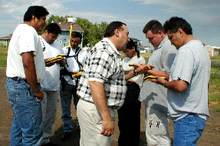
Participants in geographic positioning systems (GPS) training plot their locations on a hand-held device.

Both the Army Corps of Engineers and state governments have ignored tribal and Indian water rights in the management of the Missouri River. In the Mni Sose Intertribal Water Rights Coalition’s response to the Army Corp’s Master Water Control Manual Draft Environmental Impact Statement, the Coalition noted that the Army Corps is considering only existing consumptive uses; no potential tribal water rights are considered in the operation models.

In addition, the states have also threatened Indian water rights by invoking the McCarran Amendment. Tribal intergovernmental relations are tribal/federal relations, not tribal/state. However, when Congress waived the sovereign immunity of the United States in water rights adjudications under the McCarran Amendment, the U.S. Supreme Court allowed adjudication of Indian water rights, some of the most valuable treaty rights of the Tribes, in state courts. State governments, typically representing non-Indian water users in competition for Indian water, exert strong influences rendering no fair or meaningful state forum in which to address Indian water issues.

In the 1940s and 50s, the federal government constructed massive water facilities including dams, hydroelectric facilities, canals, navigation structure, and flood control features on or next to most of the Indian reservations. Tribal people still remember watching in horror as communities, prime bottom lands, riparian areas, forests, and grave sites were inundated by the construction of these facilities and the water siphoned away from the Reservations. While the federal and state governments conveniently ignored the tribal rights to water, benefits of these projects were siphoned to non-Indian communities.

Missouri River Basin Tribes emerged from the struggles with forced reservation life. They stand to regain control over tribal water resources, rehabilitate the lands and resources that negatively impacted by events in the 1940s and 50s and to actively participate in the prudent management of the Missouri River water resource.

The Missouri River Basin Tribes must participate in developing water resource programs and other water resource activities to fully utilize and secure the benefits to tribal members. The Missouri River Basin is beginning a period of accelerated water development and increased water regulation. The Army Corps is attempting to complete the revised Master Water Control Manual for the Missouri River System, and Western Area Power Administration will complete new power allocation process in the year 2005. The Tribes must take advantage of these windows of opportunity.
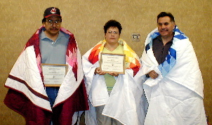
Tom Escarcega, Rhonda Azure, and Randy Perez are recognized for ten years of service as Mni Sose tribal delegates—presented May 3, 2001.

The Tribes seek to have meaningful participation in the resource management of the Missouri River Basin based upon principles of fairness and science and not politics and expediency.

The Missouri River Basin Tribes lack the technology and technical skills to participate, on a meaningful level, with state and federal agencies in the management of the Missouri River Basin.

A broad-scale and cooperative tribal resource management effort is needed to insure effective tribal participation in water resource management and development. The Missouri River Basin Tribes must compete with the Army Corps of Engineers, seven state water resource departments, and other federal/state agencies. The Tribes must contest water issues with huge federal agencies and state agencies possessing vast fiscal and human resources. Federal and state agencies use statistical techniques that do not take into account factors specific to Tribes. For example, in measuring the cost of hydropower, the lost opportunity to Tribes is not included as part of the cost.

With specific reference to the water resource, the Coalition Tribes will need to cooperate and collaborate among themselves to decide and identify alternatives regarding water resource management. Individual Tribes, especially smaller Tribes, lack the necessary fiscal resources to employ technicians and professional hydrologists to collect, analyze, and interpret data in Indian water rights issues. They need experienced professionals to advise tribal leaders and their staff on the development and management of agricultural lands and systems. These professionals are necessary to track and calculate tribal water entitlements; inventory, assess, and remediate environmental problems; evaluate and protect community health; market and develop tribal water resources; and operate tribal drinking water and waste water facilities.

Even if federal agencies involve Tribes as cooperating agencies in the management of the Missouri River, Tribes lack the resources to collect and analyze the data before making their recommendations.

The Missouri River Basin tribal natural resources and water resource offices depend on discretionary funding from federal agencies for maintenance of their operations. They derive the bulk of this funding from the Bureau of Indian Affairs and other governmental agencies, with annual funding priorities mandated by Congress. The Tribes are vulnerable to the annual fluctuations in Federal funding, which inhibit long-term planning. The agencies have neglected the smaller Tribes as to funding, training, technical assistance, and federal outreach.

In a survey conducted by the Mni Sose Intertribal Water Rights Coalition, the individual tribal water resource offices reported they were under-manned by an average of three full-time staff members. The Tribes indicated that these positions were needed in water inventory maintenance.

New federal requirements for drinking water protection, solid waste control, non-point source pollution abatement, and hazardous waste have affected Indian reservations. Tribes have been charged with implementing these legislative regulations and rules with inadequate federal funding. The Tribes must take the lead in the development of these codes and regulations or be subjected to state-imposed codes. Tribes need critical skills to carry out these programs pursuant to current and additional federal laws. Such skills include sound technical capabilities and administration, policy, and managerial skills.

Individually, the Missouri River Basin Tribes have been unable to address water rights issues due to the complex infrastructures of the federal agencies, geographical isolation, and lack of technical skills and technology.

The current legal environment for the resolution of tribal rights to the Missouri system and its tributaries is highly charged, competitive, and fast moving. Many tribal leaders perceive the legal system to be extremely threatening to tribal sovereignty.

For 20 years, the Department of the Interior has held a moratorium on the approval of tribal water codes. Efforts by tribal governments to self-govern their resources have largely been stifled. Mni Sose has been at the forefront of efforts to overturn that blockade to infrastructure development. Mni Sose has prepared a program for the development of model tribal water codes, which will allow any Tribe to adopt individually tailored laws governing the resources of the Tribe. Such a model code will save each Tribe tens of thousands of dollars in the development of their water laws. Concurrently, the Coalition is working with the Department of Justice to develop an enforcement program to back the adoption of the water codes. Without local enforcement, any attempt to regulate water use and abuse will be met with frustration.

Some states have adopted laws to quantify Indian water rights. This has forced Tribes to negotiate with states to identify quantities of Indian water. Again, the control and knowledge of the resource base and the presence of tribal water management capabilities can exert a profound influence on the positive or negative outcome of a negotiated settlement. In any case, as more states move to quantify tribal water using the state court proceedings or negotiations, many Tribes are seeking to develop their technical knowledge and skills in water resource management.

Coalition Tribes are striving to exert an active water resource management presence and improve technical capabilities in water resource development. This will reduce or eliminate the need for state and federal control of tribal resources. The Tribes would like the opportunity to develop their homelands, devising resource use and management strategies that would fit within the framework of state, Federal, and tribal laws, eliminating the need for costly litigation.

The original motivating factor that formed the Mni Sose Coalition was the concern of the Tribes over the quantification of tribal water rights. Not including any legal or negotiated proceeding, nearly all of the 28 basin Tribes are involved in some aspect of water rights development. The identification, development, management, and protection of water rights are underway. All Tribes are at different stages with respect to water quantification, water resource development, and control structure. The profound realization that tribal water rights exist even without formal adjudication has prompted many Tribes to seek ways of securing increased control over the resource through tribal resource management activities, including resource policy development.
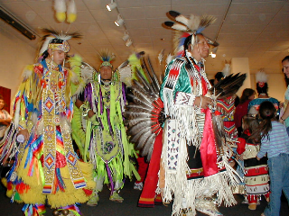
Native American dancers perform during a reception for the Tribal Emergency Management Conference held in September 2000.
Tribal lands are located in isolated, rural areas with limited access to current resource technology, expertise, and equipment. The smaller Tribes have not been able to keep pace with technology (i.e., computerized water monitoring systems), and as a result, are unable to fully assess their water resources and tribal options in water management due to lack of financial resources. Even those Tribes with some financial resources have inadequate resources to cover their million-acre plus reservation lands. Access by computer to data and expertise is an effective way to address this need.

The basis for securing the greatest amount of control over water resources, with the greatest flexibility in use over the long term, consists of three components:
- Accurate and comprehensive technical information regarding tribal resources;
- Capable and competent tribal water resource managers; and
- Strong tribal government with effective resource-governing policies.

These aspects, essential for tribal self-determination, are often overlooked in both settlement and litigation arenas. The Mni Sose Coalition has focused on these key areas in developing tribal capabilities and believes these needs exist, no matter the litigation, negotiation, or other paths taken by the member Tribes in the resolution of water resource issues.

Conflicts in the Current Management of the Missouri River

The rights of the Indian Tribes were not taken into account in the development of the Missouri River dams. This continues in the operation of these projects by the Army Corps of Engineers.

The primary theme among the Indian Nations of the Missouri River basin for sustainable economic and social development remains the fact that the Tribes contributed economic resources for the Pick-Sloan project, but they are receiving few of the benefits. Accordingly, the Mni Sose Intertribal Water Rights Coalition is working toward revisions in the operation of the Pick-Sloan project by the Army Corps to protect the environmental and cultural resources of the Missouri River basin and to ensure that the Tribes receive some of the benefits of the projects for which they have suffered so dearly.

Ironically, the current debate about the distribution of Pick-Sloan’s benefits is dominated by those who already benefit but want more. The states of South Dakota and Missouri continue to debate about water flows, with South Dakota wanting higher reservoir levels for recreation development upstream, while Missouri seeks continued releases of water to support its navigation industry. Both South Dakota and Missouri have filed lawsuits in recent years against the Corps of Engineers, advocating their respective positions in federal court.
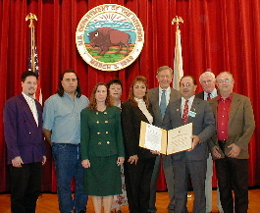
Executive Committee, Staff and Dept. of Interior Secretary Bruce Babbit with 2001 Conservation Service Award given to Mni Sose

Meanwhile, the Army Corps has estimated that its operation of the Missouri River dams contributes $1.3 billion to the national economy annually. Of that figure, one-half is derived from the sale of hydroelectricity by the Department of Energy. The remaining contribution comes in the form of navigation benefits, flood control benefits, and recreation development.

Yet, the Tribes share little of these revenues. In fact, reservoir level fluctuations impact tribal environment and wildlife habitats, and native burial grounds and ceremonial sites are subject to erosion and inundation.

Mni Sose has been engaged in a constant effort to educate U.S. agencies and Congressional committees of the treaty and trust responsibilities of the Federal government. The Coalition has worked successfully for inclusion of acknowledgments of tribal water rights in the Army Corps of Engineers’ Master Manual for the management of the Missouri River, guidelines for the sale of federal assets by the Bureau of Reclamation, and the program for tribal allocation of low-cost, federally generated hydropower for the benefit of tribal members.

Conclusion

The Missouri River Basin Tribes possess extensive land and water rights, which will enable them to be self-sufficient. However, inadequate environmental infrastructures hamper tribal development efforts. No meaningful development can exist without improved infrastructures. Consequently, improving water, sanitation, and solid waste facilities of Reservations remains a foremost concern of the tribal leadership.

Moreover, the Indian Nations of the Missouri River basin are telling the United States to stop using tribal land and water for hydroelectricity, navigation traffic, and irrigation by the homesteaders unless the Tribes are adequately compensated for the use of these resources. In addition, the federal government is using tribal resources in a manner that destroys wildlife habitats and environmental and cultural resources. There can be no sustainable development unless these resources are preserved and enhanced.

Ultimately, the approach of the non-Indian society toward Indian rights and treaties must change. Instead, Tribes are perceived as an inconvenience as the federal government and non-Indian society take and utilize tribal land and water for their economic benefit. Mni Sose will continue to exhibit the patience and perseverance of tribal ancestors in asserting these rights.

Finally, the Coalition is accomplishing what has historically been an impossible goal: bringing together the competing interests of the Missouri River Basin. The voice of 25 Indian Nations speaking with one voice is loud enough for the federal and state agencies to hear.

All of the activities of the Coalition are directed from the communities of the member reservations. Therefore, all of the Coalition’s programs have a direct impact on the long-term quality of life in those communities. The Coalition addresses those issues of basin-wide importance expressing the voice of those communities. The thoughtful and directed efforts of Mni Sose are gathering strength as the Coalition works toward greater self-governance and sustainable economies for the Native American Tribes.
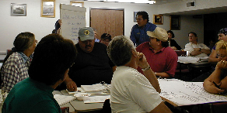
Gerald Kanosh, Emergency Response Manager for the Paiute Tribe of Utah, discusses an emergency response plan at the Community Emergency Response Train-the-Trainer course.

